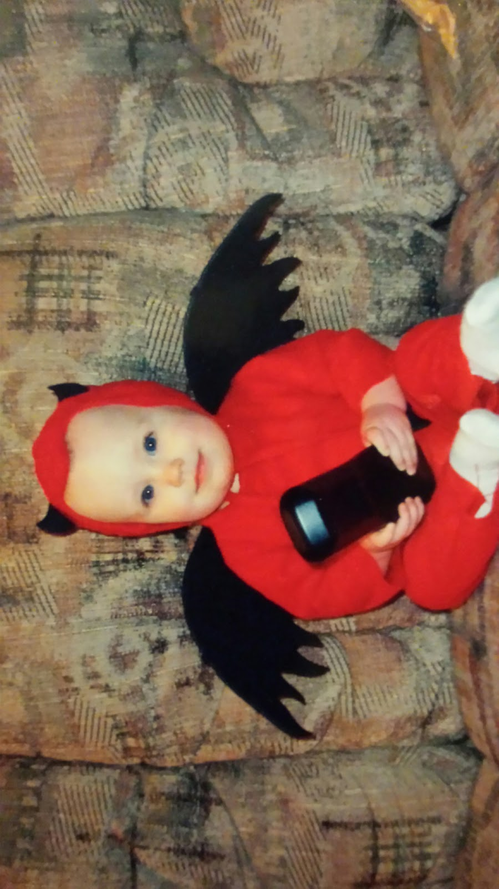

In the beginning of my life, I was sweet angel until Halloween of 2003 when I was 2 years old. On that fateful night, I went around possessing certain children. It all started when my parents told me that we weren’t going trick-or-treating. I was outraged and despondent. They put me to bed, and that’s when I commenced my work. I quickly called out to the king demon of the underworld, Crowley. I asked him to provide me my wings back so I could swoop out of the window and into the streets since I didn’t know how to walk yet. He answered me immediately and black smoke started to emanate through the walls and floors and the room. With a humongous boom, he granted me my wings. I remember them clear as day. The top was as a charcoal black and the tips were red with blood. They felt frosty and silky. My back arched, and then all of a sudden, I was in the air and gliding towards the window. I held my hand out and used my power to open the window. A crisp breeze came in through the window and sent a shiver through me. I looked around my room one last time and floated out the window. My first victim was an young girl who just a little bit older than me. She had long brown flowy hair and bright green eyes. She looked too innocent not to possess. I savagely took over her body in the blink of an eye. Her parents drove her around to every house in town. They even took her to the rich neighborhood where all they gave out was jumbo candy bars. By the time it was over, I had three immense bags stocked full of delectable Halloween candy. I guess I didn’t need to take over anyone else's body. I was jubilant and so was my full stomach. I halfheartedly abandoned her body as soon as we pulled into their driveway. I flew out of the body, grabbed the sacks of candy, and went out the car door, leaving the little girl lying lifelessly in the car seat. Don’t worry, she should be awake and remember nothing in a few minutes. I soon approached my house and opened the window. I flew in, dumped the it all over my crib and hungrily devoured the candy. The candy smelled marvelous and I couldn’t resist the urge to just eat it all. The next morning, I remember waking up lying on the mountainous pile of candy with a stomach ache. No one will ever know what I did that night. MUAH HAHAHAHA!

